**Integrated Human Practices**

Overview

More than 800 million people across the world go to bed hungry each night.

More than thousands of tons of cereals around the world are polluted by heavy metal.

According to the data from the Environmental Protection Agency in China, heavy metal contaminated arable land in China had reached 5,480,000 hectares in 2016, almost 6 times of the size of Beijing.

So, we want to rehabilitate the land to **protect the farmland, increase grain yield and ensure food security**.

In order to achieve our goals, we utilized a human-centered design process (inspired by 2019 Calgary team) to conduct our program “Soil Lead Immobilization Magician” (SLIM) to address environmental problems. After engaging with stakeholders and experts, we found what we did was far more than that.

The health of humans, animals and the environment is closely connected--that’s <b>“**One Health**”</b>. One Health is the integrative effort of multiple disciplines working locally, nationally, and globally to attain optimal health for people, animals, and the environment.

Besides, whom we want to help most is farmers and peasants, whose income is seriously damaged by the heavy metal contamination. We made a scheme --“**For Health, For Earning**” to call on people to care about their food safety and environment, so that we can help farmers and peasants to save the loss with the increasing demand in heavy-metal-free vegetables.

Now let’s see how SLIM help build a better future!

**1 Discover**

**The birth of SLIM**

It was a casual glimpse of a piece of news about lead poisoning. It was a casual conversation with a rural relative of one iGEM team member. The two incidents sowed the seed of SLIM.



**Selected from Xinhua News**

**Children Suffering from Lead Poisoning**

We felt shocked at a glimpse of a piece of news, <i>*Over half of Children in Chenzhou suffering from Lead Poisoning*.</i> A village in Chenzhou, Hunan province was polluted heavily by lead a few years ago. Chenzhou was famous for its lead-zinc deposit and large quantities of lead were detected in the farmlands. Most villagers there made a living by farming, so they were exposed to soil, crops, water and even air with leads every day.

In other words, what they ate, drunk and even breathed in has been severely polluted. There were only 23,000 children in Chenzhou, but over half of them were found to have excessive levels of lead in their blood. They had symptoms like weakened immune systems, slow growth and lack of concentration. Although it’s been 10 years and the environment has been improved, the soil is still in pollution.

This incident has drawn our great attention. **We hope we can use the approach of synthetic biology to improve their living environment and protect their health.**



**Conversation with Peasant Wang Ping**

We called Wang Ping，who said their income reduced obviously. He said that vegetables were attacked by pests, while the only solution he could come up with was the application of pesticides and fertilizers. It seemed that vegetables grew better in a short period of time. However, with high frequency of pesticide and fertilizer application, <b>**the soil was unhealthier and was inclined to agglomerate, and there were indeed fewer earthworms</b>**, resulting in a serious decline in vegetable quality and yield. He consequently suffered lower income.

Pesticides and fertilizers contain lots of heavy metals. We assume there were some relations between heavy metals, soil health, earthworms and vegetables. <b>**This little assumption inspired us to use earthworms to improve the heavy metal contaminated farmlands to increase farmland yield.</b>** We do really want to help peasants, like Wang Ping, reduce the economic loss.

**What did we want to do?**

Humans, animals and the environment are connected. In order to promote harmonious development between human and nature, we utilized synthetic biology to remedy lead contaminated soil.

We believe one day, lead poisoning will be away from children, the income of peasants will be protected, and the food safety crisis will not appear.

**2 Understand**

To get a better understanding of the relations between humans, animals and the environment, we collaborated with One Health association. After taking the advice from One Healthers, we integrated the concept of One Health into our project to shape SLIM.

**Collaboration with One health**

**<b>One Health</b>** is a collaborative, multi-sectoral, and transdisciplinary approach—working at the local, regional, national, and global levels—with the goal of achieving optimal health outcomes recognizing the interconnection between people, animals, plants, and their shared environment.

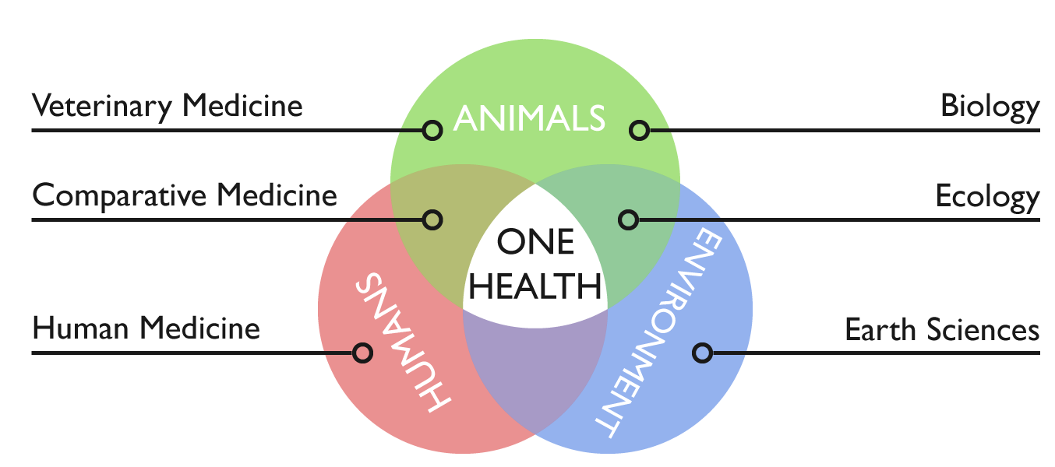

Provided by One Health Association

**One Health Club NAU,** a club organized by students, is building the NAU-UCDavis One Health Joint Center with University of California, Davis (UCD). With environmental degradation, the balance between human society and nature has been broken, causing a threat to human health. To solve the problem, One Health was born, holding a promise to attain optimal health for **people, animals and the environment** with the **effort of multiple disciplines**.

**How do we integrate the concept of One Health into SLIM? On the one hand, the tolerance of earthworms is strengthened, protecting earthworms’ safety. On the other hand, soil environmental pollution is figured out, so that we can ensure agricultural development, food safety and human health.**

We talked with Dr. Osburn, Christie and One Healthers in Lunch Time Challenge to share the story of SLIM. With them, we **learnt** how to explore the communities, institutions, or individuals affected by the problems. Most important of all is that we got kind suggestions and help from Dr. Osburn and Christie, which helped to better shape SLIM.

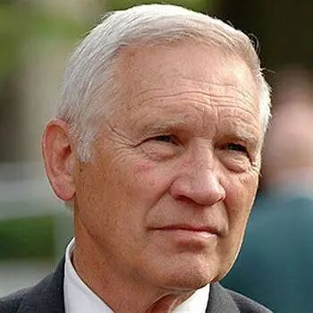

**Dr. Bennie I. Osburn**

Dr Osburn is Dean Emeritus, School of Veterinary Medicine, UC Davis and the director of Outreach and Training in Western Institute for Food Safety & Security. WIFSS is a University of California, Davis program of the School of Veterinary Medicine and the College of Agricultural and Environmental Sciences. In order to facilitate a better understanding of the complex interactions of humans, animals and the environment, multidisciplinary centers, institutes and programs, including WIFSS, were organized and developed during his tenure as dean.

**What did we know from him?**

* Concept of One Health
* People’s concern about health
* Effect of soil lead contamination on human health

What we do can contribute to the protection of food safety, and we can demonstrate our works by utilizing a One Health approach. So, we plan to consult experts in the health of humans (especially in blood lead), animals and the environment.

*“Yes, <b>****One Health is the integrative effort of multiple disciplines working locally, nationally, and globally to attain optimal health for people, animals, and the environment.</b>*** *I’m glad that you can utilize a One Health approach in your project. In my views, what people care about most is their health and freedom from disease. We often fail to consider the environments role with health problems affecting people, plants and animals. The topic your team has selected to study, lead toxicity, is an excellent example of an environmental problem affecting human health. Young children are often affected with lead poisoning because of contaminated, air, water or foods. Lead toxicity can affect neurological and cognitive development. There is a need for creative thinking of ways to mitigate the toxic effects of lead that is in the environment, so finding new ways of detoxifying the chemical or partitioning it out of the food or water supply is also attractive.”*

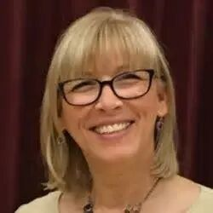

**Christie Marie Brunner**

Chris Brunner, as a communications and international programs director in WIFSS, devotes herself in education of One Health. She always holds an open mind to take in novel ideas and are kind enough to share relevant information.

**What did we know from her?**

* Health of the soil related to health of ALL living things
* Importance of teamwork and collaboration
* Information about relative researches
* Recommendation Dr. Jorge L. Mazza Rodrigues to us

We are determined to make a brochure to help people understand that we are all connected, from the soil to the table, and that goes for everything in between: plants, animals, water, air ... Besides, we spread the good word about One Health in cooperation with other iGEM teams.

*“I am thrilled to know young adults such as yourself are addressing soil health and food safety through the comprehensive One Health approach. You and I know that One Health helps us by understanding that lead is naturally in the earth’s crust and once it is mined and processed it does not break down, instead it again covers the air and landscape where it is picked up by plants, animals and people.   Once it enters animals and people it causes illness and even death.  For this reason, it is important that we attempt to find ways to prevent plant, animal and human illnesses.  We care about the health of the soil as it relates to the health of ALL living things.  One Health is a difficult thing to translate to a farmer who is concerned about meeting financial obligations. When you can demonstrate that having healthy soil will allow him or her to grow more crops and make more money and provide healthy food for his or her family, and the community, the light bulb goes off and it becomes easier to make the connection between the health of the soil and the health of people.”*

**Key stakeholders and experts’ interview**

1. **Human Health**

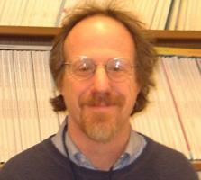

**Dr. Joseph Bressler**

Dr. Joseph Bressler is an expert in environmental health and blood lead from The Johns Hopkins University.

**We want to know…**

* How blood lead affects children
* Effective treatments of blood lead

**What did we know?**

* Lead disease is difficult to cure, and the best treatment is to prevent.
* Chemical phosphate can insolubilize lead, thereby preventing lead diffusion.

Inspired by Dr. Joseph, **we planned to use engineered bacteria to produce phosephate.**

*“It’s difficult to cure and the best treatment is to prevent. In children, the toxicokinetic of lead include absorption through the intestine via iron and calcium transporters, transfer to the blood (99% in rbc and 1% in serum), distribution to soft tissues (e.g. brain and kidney), and storage in the bone.  The bone lead remains throughout one’s life and might re-enter the blood when there is bone loss during aging. There is a strong relationship between blood and impaired cognitive development at all blood lead levels. There is no blood level thought to be safe. This is very different from other contaminants that do not increase the risk of cancer.”*

*“The rate of lead poisoning in America has declined sharply. Polluted soil is not often to see in America. However, old water pipes remain the most important problem. When water is treated with chlorine, the acidity increases leaching of the lead from the pipe, the water companies are obligated to test and adds a chemical (phosphate) to insolubilize the lead thereby preventing lead from entering the water supply. This is what happened in Flint, MI but the water company did not add phosphate.”*

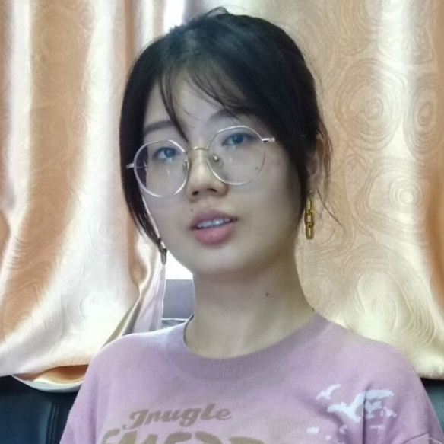

**Inspector Xu Ningyue**

Xu Ningyue is an inspector of agricultural products from The Committee on Agriculture.

**We want to know…**

* Sources of heavy metals
* Impact of heavy-metal-polllution on food safety

**What did we know?**

* **It’s common to find problems of excessive heavy metals in agricultural products.**
* Exogenous pollution and endogenous pollution
* Twelve million tons of vegetables and crops are polluted.
* A policy: Control of Soil Risk Management in Agricultural Land

*“It’s common to find problems of excessive heavy metals in agricultural products, such as cadmium in paddy and lead in vegetables. The sources of heavy metals are very extensive, like industrial pollution, pesticide residues and automobile exhaust. The pollution can be divided into two parts-- exogenous pollution and endogenous pollution. The former like pesticide residues and bacteria can be easily eliminated through common wash and cooking, but the latter not. So, the only way to prevent it is to stop the gathering in vegetables. That is to solve the environmental problem. In China, 12 million tons of vegetables and crops are polluted by heavy metals every year, causing an economical loss of 20 billion yuan. The biggest losers are peasants.” Ms. Xu advised us to get more information from the policy released by the government, Control of Soil Risk Management in Agricultural Land, from which we knew heavy metals pollution is widespread in China.*

**(2) Environmental Health**

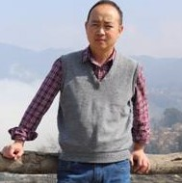

**Professor Guo Xianhua**

Professor Guo Xianhua is an expert in heavy metal pollution treatment from Chongqing Three Gorges University.

**We want to know…**

* The situation of lead contamination
* Existing methods of heavy metal pollution

**What did we know?**

* Merits and demerits of existing methods

|  |  |  |  |
| --- | --- | --- | --- |
| Methods | Applied Range | Cost | Risk |
| Plant processing | Heavy pollution  Large area | Relative low cost | Easy to cause second pollution |
| Soil amendments | Short-term emergency | -- | Resorption of pollutants |
| Physical methods | Small area | High cost | -- |

* Lead pollution map of China

Professor Guo advised us to **produce phosphate enzyme**, because there’s much insoluble phosephorus but little phosephate enzyme. Phosphate enzyme can transform insoluble phosephorus into soluble one, which in turn combines with lead. According to the census shared by Professor Guo, polluted areas are often near lead-zinc deposits, like southwest and middle-of-south in China. **We aim to apply it to southern China.**





Professor Li Zhen is an expert in soil heavy metal treatment from Nanjing Agricultural University

**We want to know…**

* Stability of pyromorphite and safety of forming pyromorphite in soil
* Efficiency of employing immobilization approach in soil environment
* How to verify the formation of pyromorphite in soil

**What did we know?**

* Exceptional stability of pyromorphite
* Feasibility of extending previous research to soil environment
* Employing XRD analysis to verify the formation of pyromorphite in soil.

*“Although previous research on the formation of pyromorphite was carried out in the water system, it can be extended to the soil system. It is also safe to treat lead ions by forming pyromorphite in the soil environment, because pyromorphite is extremely stable, and effective lead cannot be extracted with TCLP (US EPA standard). In addition, many phosphate-solubilizing microorganisms in the soil are very tolerant to lead and are basically unaffected. Organic bonding state of lead in soil and other forms may affect the formation of pyromorphite, but it should not be very serious, because from the chemical balance, pyromorphite is almost the most stable lead-containing mineral. If you want to analyze and prove whether there is pyromorphite formed in the soil environment. XRD is the most effective method.”*

1. **Health of Animals**

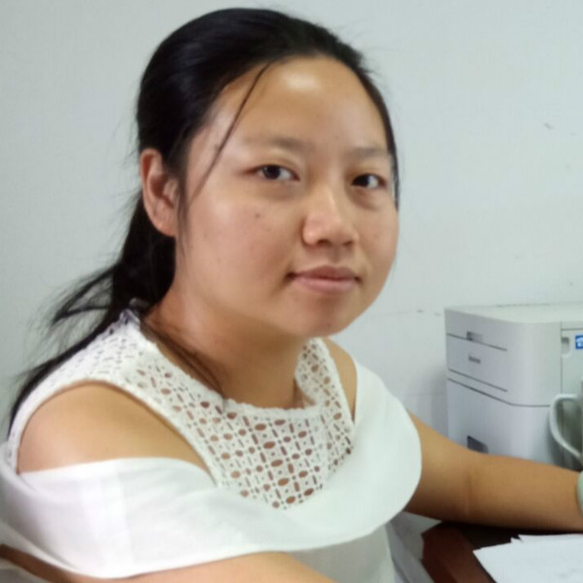

**Researcher Zhou Peixiang**

Zhou Peixiang is a researcher in management of excrements pollution of livestock and feed safety from Animal Health and Safety Center.

**We wanted to know…**

* Effect of heavy metals on animals
* Heavy metal pollution in stock-breeding

**What did we know?**

* Heavy metal pollution causes a considerable economic loss to stock-breeding.
* **Earthworms are tolerant to heavy metals to a certain extent.**

Earthworms are tolerant to it, to a certain extent. So, it’s safe for them in heavy metal contaminated soil.

*“In fact, there are plants using earthworms to remove the heavy metals in excrements of livestock and poultry. The excrements contain heavy metals, and earthworms are tolerant to it. Moreover, feed is sometimes detected with heavy metals. This has a huge impact on animal productivity, causing a considerable economic loss to stock-breeding. It can also affect human health through the food chain.”*

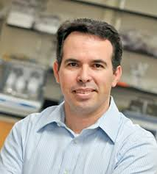

**Dr. Jorge L. Mazza Rodrigues**

Jorge, a professor in the Department of Land, Air and Water Resources, specializes in soil microbiology. His research interests are microbial ecology, tropical forests, land use change, biodiversity, metagenomics, metaproteomic, ecological genomics, lignocellulose conversion, microbial physiology.

**We wanted to know…**

* Dominant bacteria in soil and earthworms
* Role of microorganisms

**What did we know?**

* ***Bucillus subtilis* is the dominant bacteria in soil and earthworms.**
* Benefits of microorganisms
* A question about **bio-safety**, “Is there a possibility that engineered bacterium cause biological contamination?”

We planned to use ***Bucillus subtilis*** as engineered bacterium, and we added **a kill switch to ensure the bio-safety.**

*“Bucillus subtilis is the dominant bacteria in soil. There are many benefits of microorganisms interacting with plants: microbes help with biocontrol of other microorganisms, promote nitrogen fixation, provide growth through hormones, allow for nutrients to be recycled and stabilize soil preventing erosion.”*

1. **Agricultural economics**

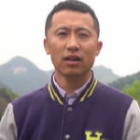

**Agricultural Economist Pei Haiyan**

*Pei Haiyan is an agricultural economist in Gui Zhou Province and devotes himself in agricultural economy.*

**We wanted to know…**

* How can we help farmers and peasants by SLIM?

**What did we know?**

* Conduct an investigation of consumers' willingness to buy pollution-free vegetables

*We attended a lecture, and raised some questions to him. He showed great confidence in our project and the development of organic agriculture. He said peasants can get a lot by developing organic agriculture. If we can promote pollution-free vegetables properly, there will be more consumers choosing them，which may bring more income to peasants. Moreover, he suggested us to investigate consumers' willingness to buy pollution-free vegetables and their concerns about it.*

**3 Create**

Through conversations with experts, we have known the health of the soil relates to the health of ALL living things, and what we are doing is responsible and good for the world. However, there is some distance left before SLIM walks out from lab to the field. In this part, to study the beneficial relationships of stakeholders, we created a scheme “For Health, For Earning” to engage with the concept of One Health.

**For Health, For Earning**

“For Health, For Earning” is a scheme to let consumers get healthier food and help peasants get more income. In this “Circle of Stakeholders”, government officials encourage agricultural entrepreneurs to buy SLIM earthworms to remedy lead-contaminated soil. Peasants work on production of green vegetables. When more people choose green heavy-metal-free vegetables for their health, more income the peasants can get.

As Chris said, “if we can demonstrate **<b>that having healthy soil will allow him or her to grow more crops</b>** and make more money and <b>**provide healthy food for his or her family, and the community</b>**, the light bulb goes off and it becomes easier to make the connection between the health of the soil and the health of people.”

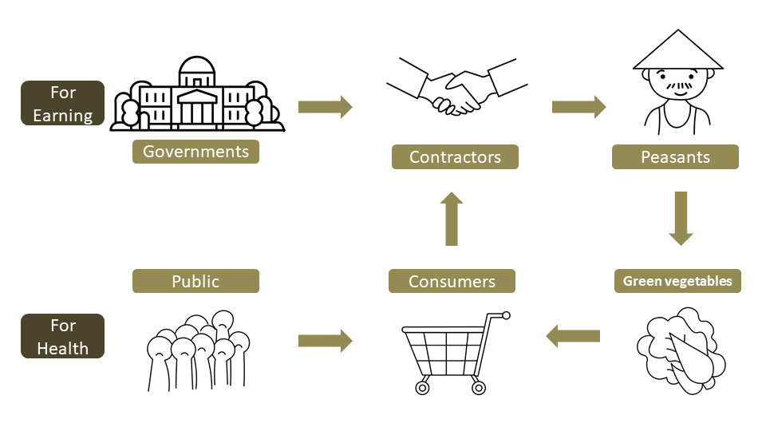

**4 Implement**

By reaching out to and learning from diverse communities, our team is also creating opportunities for broader public to help shape the practice of synthetic biology. In this part, we invited **stakeholder** input, who may have different and sometimes conflicting values that can be equally valid.



A Government Official

**We wanted to know…**

* Whether there is a policy about using synthetic biology to remedy contaminated areas.
* If governments could help us to encourage enterprises to buy our SLIM earthworms.

**What did we get?**

A government official said, “In fact, we’ve done lots of work on environmental protection. There’s already been **some policies associated with the protection of farmlands, indeed some of them are related with synthetic biology.** Having healthy soil can boost economic development and solve the poverty problem, so the government often encourage cooperation between enterprises and peasants and help them to sell more products. If you want us to help promote cooperation, **your project must be approved by the relevant agency to ensure safety** and effectiveness. It’s not a simple thing. ”

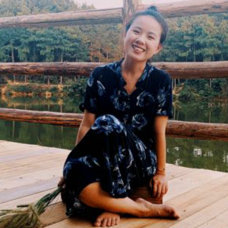

An Agricultural Enterpriser

Xiao Yuan

**We wanted to know…**

* If enterprisers could adopt our project to remedy unhealthy earth.
* How much benefits peasants can get from the enterprises.

**What did we get?**

We interviewed Xiao Yuan, an agricultural enterpriser. She said, “We use a mode of “peasants + cooperation+ family farm”. In China, most farmlands are owned by peasants, so it’s really hard to buy all lands to develop planting. Thus, **we rent people’s lands and pay them for working agriculture, that’s a more stable job than before, attracting many people cooperating with us.** We have helped more than 3,000 people find jobs and paid 5,317 million yuan in wages. I have known about the way of using earthworms to improve soil, but what I’m concerned about most is the cost. As we all know, it’s much more than just the cost of SLIM earthworms. The expenses of labour and technique and the loss of earthworms all should be considered. **If your method is cheaper and more effective than others, I’ll adopt yours.**”



A Farmer

**We wanted to know…**

* If peasants can get interests from this circle and what they are really want.

**What did we get?**

An agricultural worker in a planting industry said, “Now I am working on a farm and has rented the land to the enterprisers. **I’m content with my present life, because I get a steady income**. If our company **sells more fruits and vegetables**, I'll get **more money** and no longer have to worry about the basic needs.”

Consumers

**We wanted to know…**

* If consumers would choose SLIM green vegetables and what they are concerned about.

**What did we get?**

In this part, we made a questionnaire. To know more, please click the button.

**Information Sheet**

**Questionnaire**

**Findings**